Lab 5: Watersheds
- Delineate a watershed for both topographic maps below. Use the red circle as the given outlet and the red star as the start point (headwater). Tip: use a pencil if you have one, or map out the watershed with dots first, and draw the line when you are confident with your answer. (5 pts)
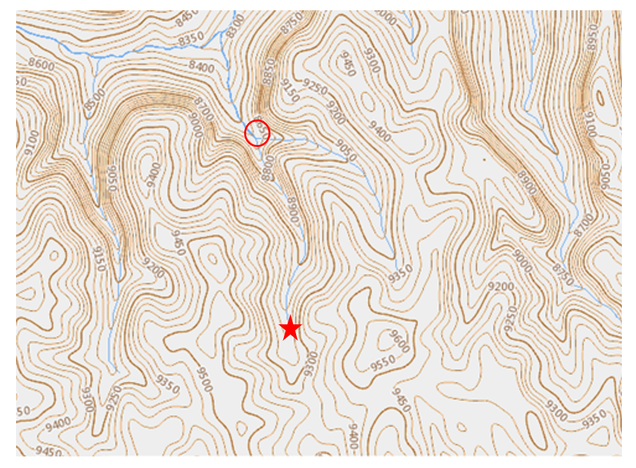
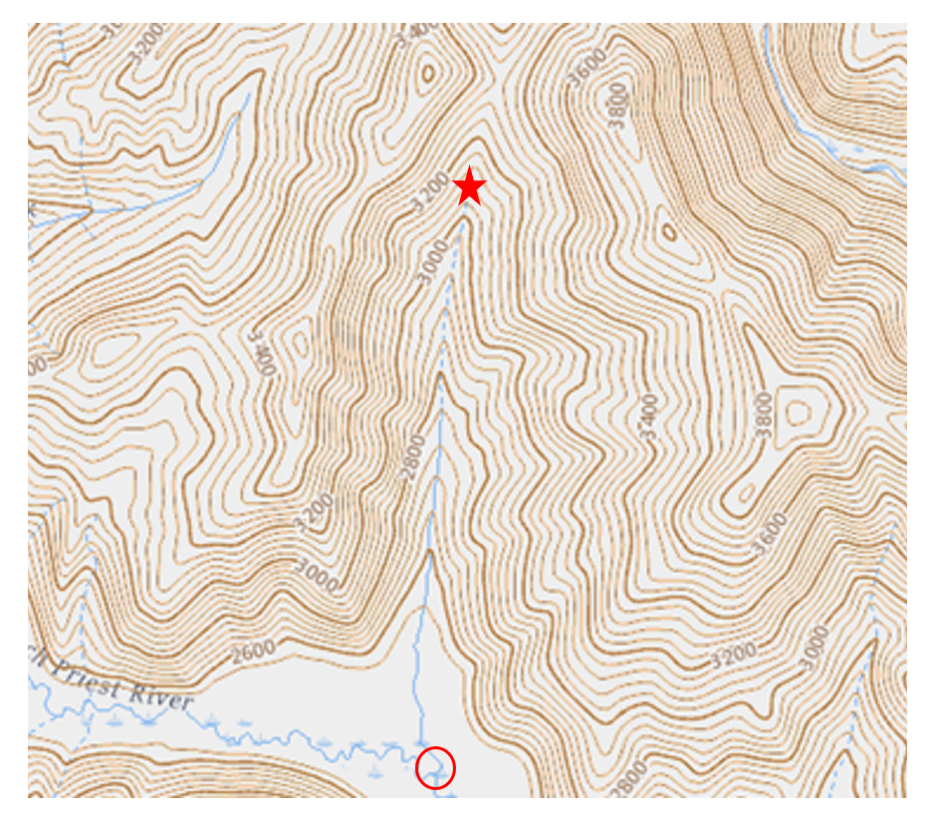
- Create two simplified water budgets for Champaign, IL and Austin, TX weather stations. The table below contains data on precipitation (P) and potential evapotranspiration (PE) for both locations. Use the graph paper provided (page 3) to create plots for precipitation and potential evapotranspiration in Champaign (graph 1) and Austin (graph 2). Don’t forget to label your lines and axes. Mark on your graphs (using different colors or patterns) the following regions on the plots: (5 pts)
  - You can also use the Excel sheet provided on Canvas (under week 7 module) to create the graphs and then submit the excel file on Canvas (you will find an option to upload the excel file under Canvas assignment “Lab 5”). If you choose to use Excel, write “Excel” next to the chart below
- Net supply – The time periods where precipitation is greater than potential evapotranspiration
- Net demand – The time period where potential evapotranspiration is greater than precipitation
 | Champaign, IL |  | Austin, TX
Month | P | PE | P | PE
January | 46 | 0 | 57 | 78
February | 46 | 0 | 60 | 83
March | 67 | 57 | 64 | 116
April | 89 | 82 | 58 | 139
May | 108 | 105 | 68 | 167
June | 113 | 116 | 111 | 177
July | 100 | 121 | 62 | 183
August | 82 | 112 | 41 | 173
September | 74 | 92 | 63 | 145
October | 80 | 73 | 100 | 122
November | 82 | 48 | 75 | 93
December | 65 | 0 | 57 | 79
* All units are in millimeters
- Describe the seasonal trends in net water supply and net water demand for Champaign. Are periods of net supply more common than periods of net demand?

- Is there any time during the year in which a net supply of water exists in Austin?

- Austin gets its drinking water from Lake Travis, a reservoir created by damming the
Lower Colorado River. Austin enters water restrictions nearly every year- do you think the data justify these restrictions? What lead you to this conclusion?

Graph 1: Champaign, IL
Graph 2: Austin, TX

